WCST FAMILY BUDDY PROGRAM INFORMATION
Welcome to the Walnut Country Swim Team!
Spirit and community bonding is a crucial part of a successful team. Being new to the swim team can sometimes be overwhelming and confusing. This year we are continuing The Family Buddy Program. This program is a way for our returning WCST families to help our new families with logistics of maneuvering a swim meet and other questions. Plus, it’s a great way to build team spirit among our swimmers.
I WANT MY FAMILY TO BE A BUDDY FAMILY. - HOW DO I SIGN UP?
Simply fill out the information below and return it to the booster team by May 12, 2023**. Your buddy info will be given out at Time Trials. Please don’t forget to indicate if you are an existing family or a new family.

WHAT DO I DO FOR MY BUDDY FAMILY?
Once you find out who your buddy is, introduce yourself. When you receive your buddy family’s info sheet, get ready to be a buddy to them. Here are some ideas:
- Invite them to sit with you at swim meets.
- Say hello when you see them at swim practice.
- Introduce your swimmers to your buddy family.
- Share a meal.
- The possibilities are endless…

We will have designated buddy exchange days twice a month during home swim meets. These dates will be announced in the weekly email and posted on social media.

This program is designed to help our new families become a knowledgeable part of our swim family. Thank you for your participation!

GET CREATIVE AND HAVE FUN! EVERYONE LOVES ENCOURAGEMENT BY THEIR FRIENDS AND TEAMMATES!
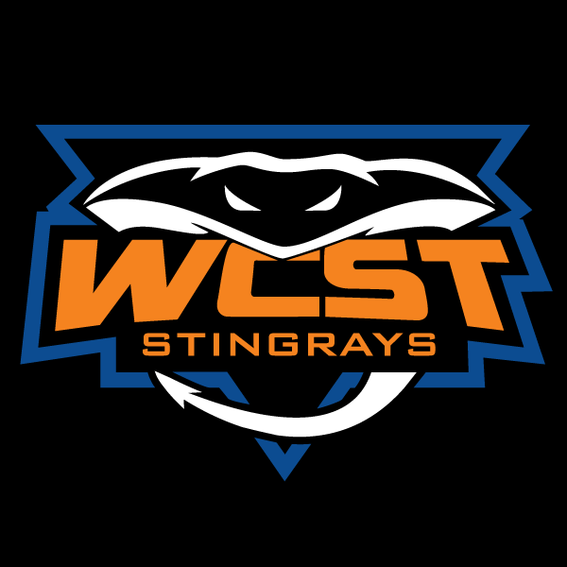
**Please note, we will accept late submissions and do our best to match your family, however there may be a chance that we are unable to make a match.

BUDDY FAMILY INFORMATION SHEET
Complete the form below with information about yourself and return to the WCST Booster’s folder in the Family Folders on deck by May 12, 2023

RETURNING FAMILY NEW FAMILY (circle one)
FAMILY NAME: ____________________________________________

ADULT NAME(S): ____________________________________________

AGE GROUP (circle): Little Ray/6&U 7/8 9/10 11/12 13/14 15-18
SWIMMER NAME:
AGE GROUP (circle): Little Ray/6&U 7/8 9/10 11/12 13/14 15-18
SWIMMER NAME:
AGE GROUP (circle): Little Ray/6&U 7/8 9/10 11/12 13/14 15-18
SWIMMER NAME:
AGE GROUP (circle): Little Ray/6&U 7/8 9/10 11/12 13/14 15-18
SWIMMER NAME:
WHAT OUR FAMILY LIKES TO DO FOR FUN WHEN WE AREN’T SWIMMING!

FOOD ALLERGIES: __________________________________________________________________________________
FAVORITE MOVIES: ________________________________________________________________________________
FAVORITE SNACKS: ________________________________________________________________________________
FAVORITE BOOKS: _________________________________________________________________________________
*Please attach additional swimmers if needed.

